**Strategic Direction**

**Mission:** Empowering world-class financial services leaders through cohort-based online education, fostering mentorship, collaboration, and excellence to develop and present transformative business plans that advance the financial planning profession.

**Values:** The core values are collaboration, diversity, community, independence, excellence, service, and growth.

* Collaboration emphasizes shared learning through tools, coaching, and forums, fostering curiosity, growth, and integrity.
* Diversity promotes inclusivity, fairness, and broad learning from varied experiences and expertise.
* Community builds a sense of belonging and mutual support, reinforcing friendships and autonomy.
* Independence and autonomy value individual growth while encouraging collective support and respectful relationships.

**Vision**: To deliver world-class financial leaders to the global community through innovative education, diverse, collaboration, and the highest standard of excellence.

**Strategic Plan**

1. **SWOTT**

| Internal | External |
| --- | --- |
| Strengths   * CBPL's highly qualified leadership practitioner-faculty * Faculty has near-perfect teaching scores history from CLF. * The faculty has outstanding industry experience that could be replicated in any work environment. * There are a lot of leadership training courses or degree programs, but almost none in financial services in the U.S. (see PDF file for the FINRA analysis) * Accelerated programs compared to traditional higher education institutions. * Mimic traditional higher education institutions in 1) learning management system, 2) narrative course content, 3) summary of the content. | Opportunities   * AI * The current administration created a vacuum of true leadership skills. * Get in front of the regional and national financial services firms to promote the program. |
| Weaknesses   * It needs to deliver the training as a non-college course. * It is offered virtually but in five days, like the eMBA course. (with all 3 courses) * Having a CPBL GPT platform for alumni or designees as a form of subscription is also essential. * The learning platform might need to have the following:   + Grading with feedback   + Discussion board/talkboard - This needs to be done with the course itself. * Keep the assignment to the minimum * Do all the exercises (discussions) in the classroom. * Zoom recording is available within the platform. * The content alignment of the 3 courses to avoid duplication. * We should not rely too heavily on AI to provide the content. It gets diluted on each AI run. | Threats   * Advancement and speed of AI in leadership offerings. * A potential cut in training dollars as the expected recession in the new administration shake-up. * The financial market risk of recession in the new administration shake-up. |
| Trends   * AI leadership tutoring and coaching * Tend to take certificates from well-known higher education institutions. * Online is convenient for learners and cheaper without travel costs. | |

1. **Strategic Goals (see section C first).**

B.1 *To increase product (courses) quality in LMS, accessibility, and faculty training by 2025*.

B.1.1 To select an LMS platform that is closely aligned with training industry LMS (such as Canvas, Blackboard, Moodle, Google Classroom, etc.) by Aug 2025.

B.1.2 To move current content from Learndash to the selected new LMS by Oct 2025.

B.1.3 To train all qualified faculty in operating within the new LMS by Dec 2025.

B.2 *To develop course-unique content in faculty leadership experience in case studies by 2025*.

B.2.1 To develop consistency in the content framework by Aug 2025.

* + 1. What are the leadership issues? (1-3 the most)
    2. What does the science say in these leadership issues? To directly reference textbooks and the latest research.
    3. What DPC/do we think based on the science?
    4. What can you as a leader do from the above?

B.2.2 To develop unique case studies from faculty’s experience by Oct 2025. Here is a suggested framework:

* + 1. What is the leadership issue?
    2. What was the background of the firm. What was the faculty’s experience that solved the issue?
    3. What are the suggested case solutions?
    4. What can you as a leader do from the case?

B.3 *To develop a program targeted promotion by 2025*.

B.3.1 To select ten (10) targeted financial services firms by Aug 2025.

* + 1. To select one type of financial services firms. For example, broker-dealers such as LPL, etc.
    2. To select ten (10) targeted financial services firms within one type above.

B.3.2 To present at these targeted financial services firms’ annual or regional conferences. To use the unique case studies as a presentation for promotion.

B.3.2 To record these presentations and continue to promote them on social media using a YouTube channel as a base.

1. **Organization-wide Strategies**

I recommend three organization-wide strategies: 1) To increase product (courses) quality in LMS, accessibility, and faculty training by 2025. 2) To develop course-unique content in faculty leadership experience in case studies by 2025. and 3) To develop a program targeted promotion by 2025.

I recommend two different product packaging: 1) remain in the current three eight-week structures and 2) one-week training.

The best practice for delivering CPBL is in one week instead of three eight-week structures. One week of online learning could help leaders apply quickly. Delivering training in a higher education institute’s format is unnecessary. The key is post-training with a mastermind group included in the pricing and optional 1:1 coaching after that.

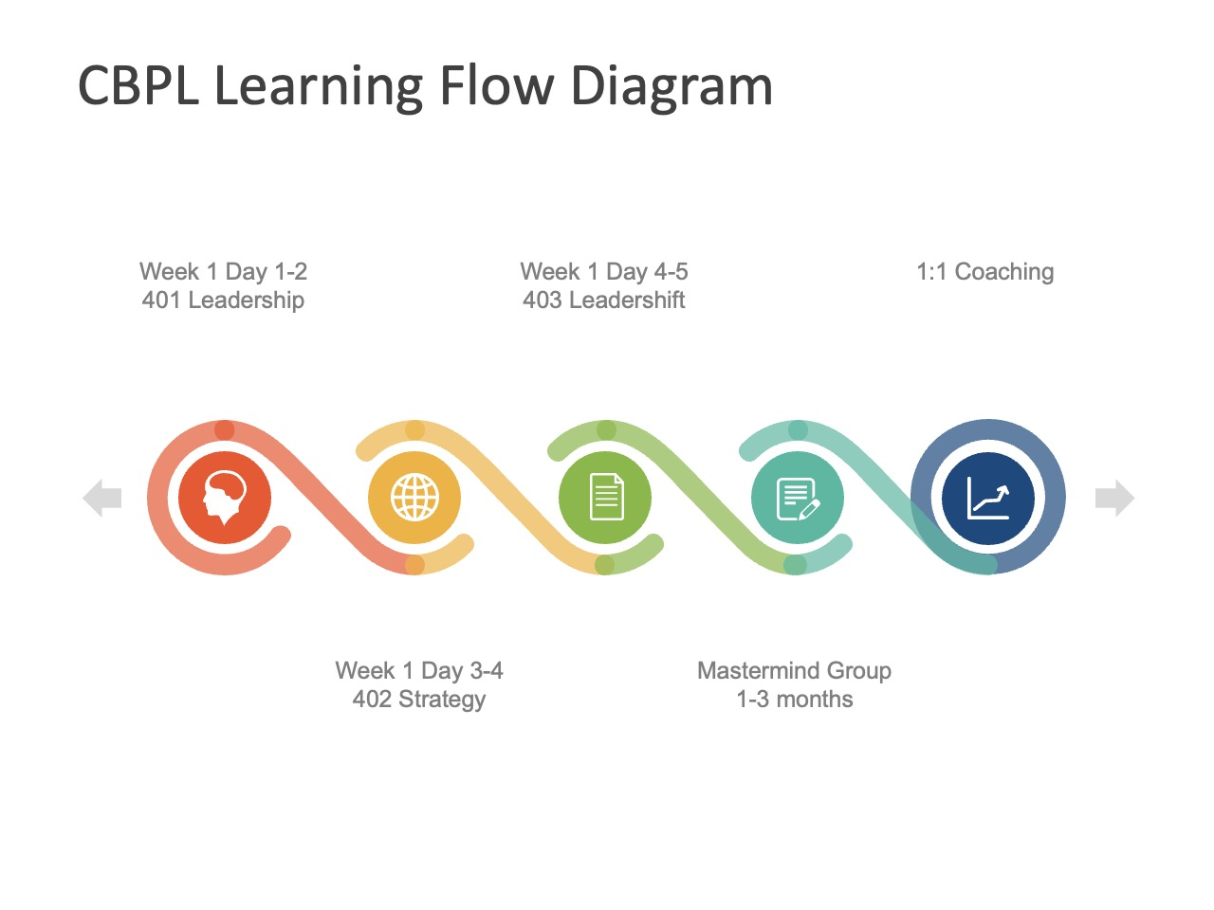

C.1. **Three eight-week structures**: This structure emulates the traditional higher education institution offerings. The target audience is those who have time to learn. The time is three eight weeks or 26 weeks to complete CPBL.

C.2. **One-week accelerated training** (short for **accelerated CPBL**): The accelerated CPBL structure emulates the traditional training offerings. The target audience is those already in a leadership position who need rapid learning like eMBA to apply to their team quickly. The need for CPBL credentials is not as urgent, but the timely implementation is crucial. The accelerated CPBL can be offered before or after the event at the annual DPC conference or retreat.

1. **Growth Strategies**

I recommend staying focused on the financial services industry or financial planning profession. To have 100 designees by 2026 by targeting one specific type (broker-dealers) of the firm. DPC could consider expanding a second type of firm (RIA fee only) by mid-2027. To have 2,000 designees by 2030.

**BTP Objectives and Tactical Action Plan**

Objective of **B.1 To increase product (courses) quality in LMS, accessibility, and faculty training by 2025**.

**Tactical Action Plan**:

* Evaluate and select a new industry-aligned LMS platform (Canvas, Blackboard, etc.) by August 2025.
* Migrate all existing course content from LearnDash to the selected LMS by October 2025.
* Provide comprehensive LMS training to all CPBL-qualified faculty by December 2025.

**Responsibilities**: Academic Technology Lead, Instructional Designer, and Faculty Coordinator.

**Resources Needed**: LMS vendor demos, IT support, budget for platform licensing, faculty training sessions.

**Timeline**: June – December 2025.

**Performance Metrics**:

* New LMS platform implemented by Aug 31.
* 100% course migration completed by Oct 31.
* 100% of faculty trained and certified in new LMS by Dec 15.

Objective of **B.2: To develop course-unique content using faculty leadership experience in case studies by October 2025**.

**Tactical Action Plan**:

* Create a standardized content framework for all CPBL courses by August 2025.
* Collect 3–5 faculty case studies that address real-world leadership issues by September 2025.
* Design course modules around these case studies, incorporating embedded reflection and discussion prompts, by October 2025.

**Responsibilities**: Content Development Team, with input from faculty contributors.

**Resources Needed**: Faculty narratives, case study templates, instructional design support.

**Timeline**: July – October 2025.

Performance Metrics:

* Framework approved and adopted by Aug 31.
* Minimum of 5 unique case studies integrated into the curriculum by Oct 15.
* Peer-review of case-based content completed by Oct 31.

Objective **B.3: To develop a targeted program promotion strategy for CPBL by the end of 2025**.

**Tactical Action Plan**:

* Identify and prioritize 10 financial services firms (e.g., broker-dealers) as target partners by August 2025.
* Develop tailored marketing collateral and case-study-based presentations for these firms by September 2025.
* Schedule and present at annual or regional events hosted by selected firms by December 2025.
* Record and share presentations via CPBL's YouTube and social media to extend reach.

**Responsibilities**: Marketing & Partnerships Team, in collaboration with DPC presenters.

**Resources Needed**: CRM tools, marketing budget, video production tools, branded slide decks.

**Timeline**: July – December 2025.

**Performance Metrics**:

* 10 firms selected by Aug 15.
* 2 pilot presentations completed (1 corporate, one nonprofit) by Oct 15.
* 3+ promotional recordings published online by Dec 15.

**References:**

Competitive Analysis from FINRA designations.

